**CREATION OF VPC, NAT , PUBLIC AND PRIVATE SUBNET IN AWS USING TERRAFORM**

**Vpc.tf**

**In this file we are creating vpc ,3 public and 3 private subnets ,route table and route association .**

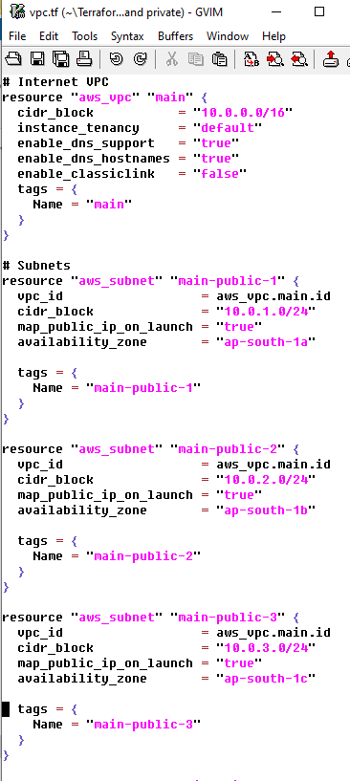

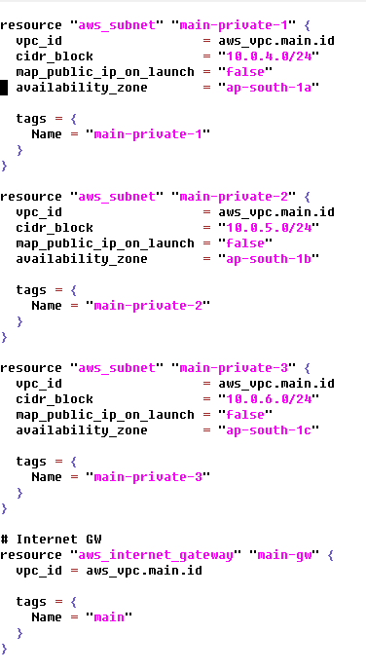

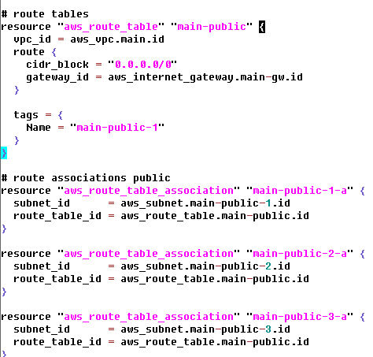

**Vars.tf**

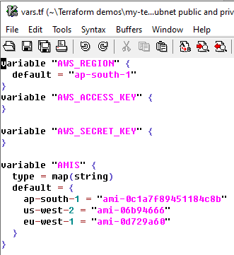

**Nat.tf**

**In this we are creating nat gateway for private instance**

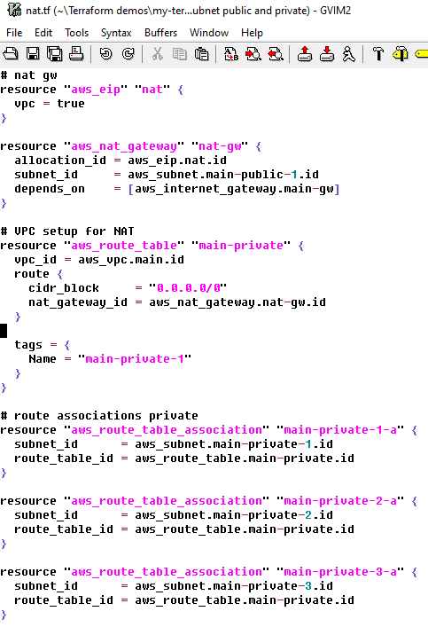

**Provider.tf**

